**Application load balancer:**

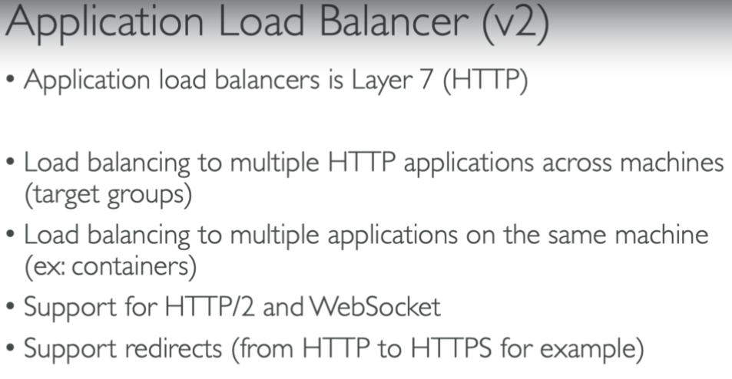

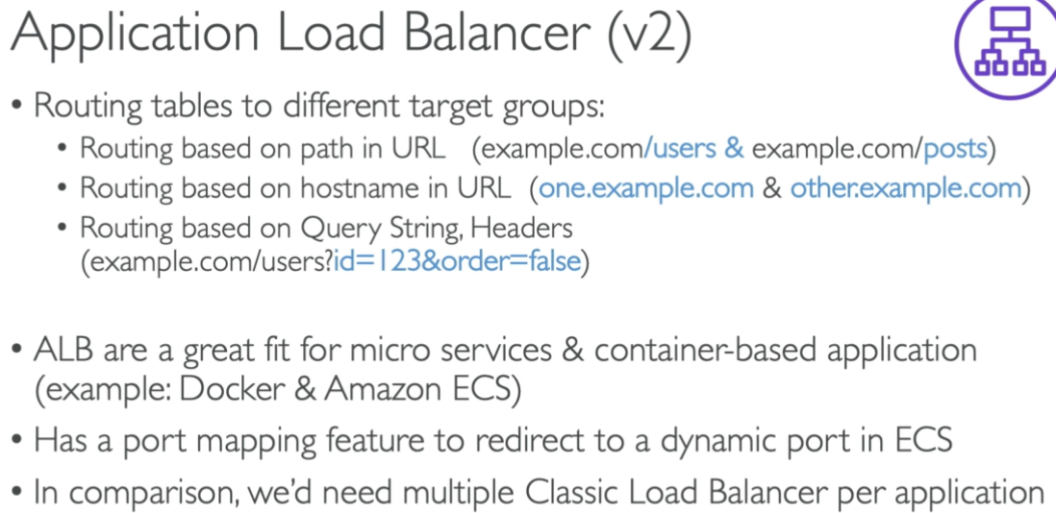

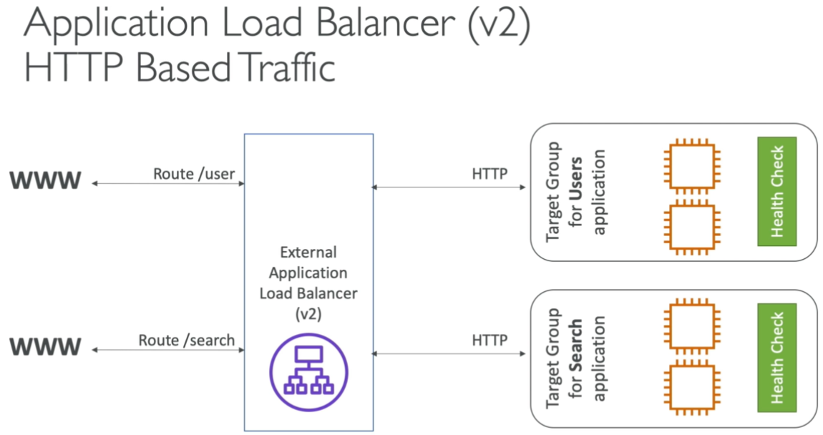

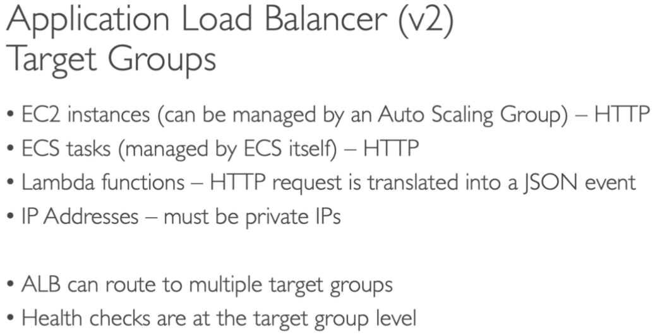

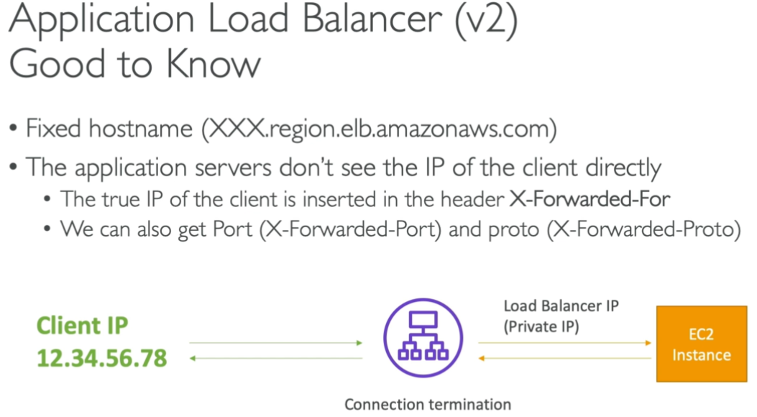

* This is for HTTP and HTTPS requests only.

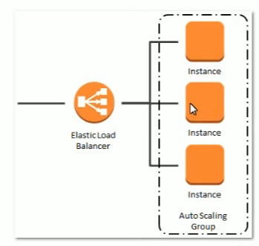

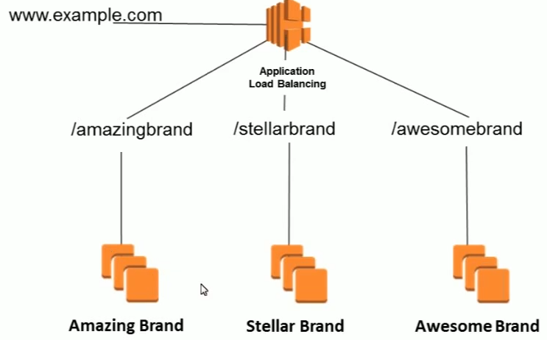

* Load balancers are heavily charged
* Classic load balancer just routes the traffic to instances
* But application balancer will help to exact instance where exactly the load needs to be transferred
* ELB doesn’t have any IP address to access. We have DNS name to access with. It has A record

**Target group:**

* Now, as per the above image. If we want to configure like it should go to amazing brand when we say /amazing brand and it should go to Steller brand when we say /Steller brand
* Target group is nothing but making group of instances to route the traffic

**Hands on:**

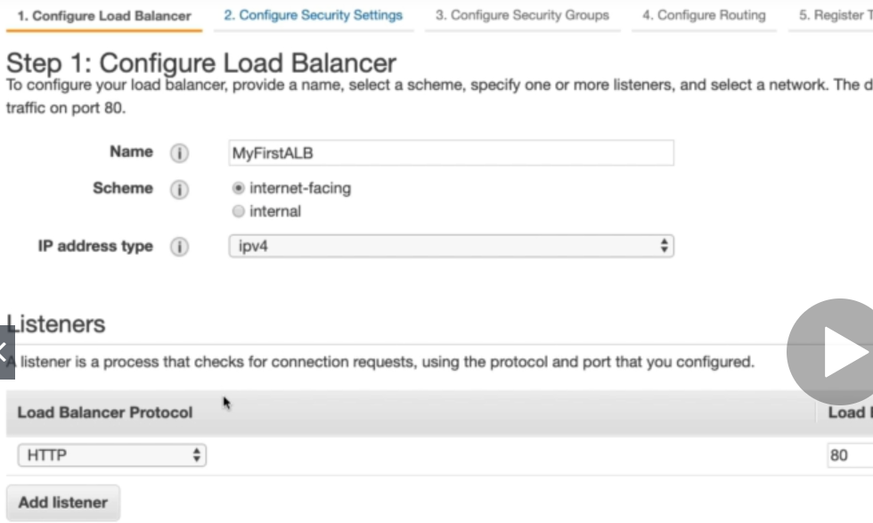

* While create an ALB. We need to give a name, select internet-facing or internal purpose and IP address type
* Also give the protocol and IP of the load balancer as above.

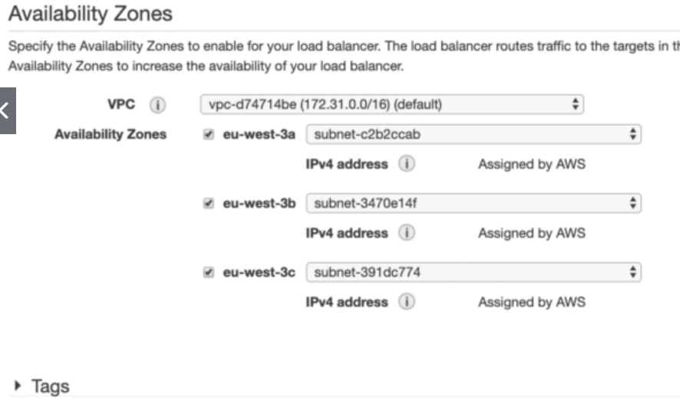

* Under that, we need to select VPC and availability zones. Give tags if we want to.
* In next step, we can configure security setting if we give HTTPS protocol to the load balancer.

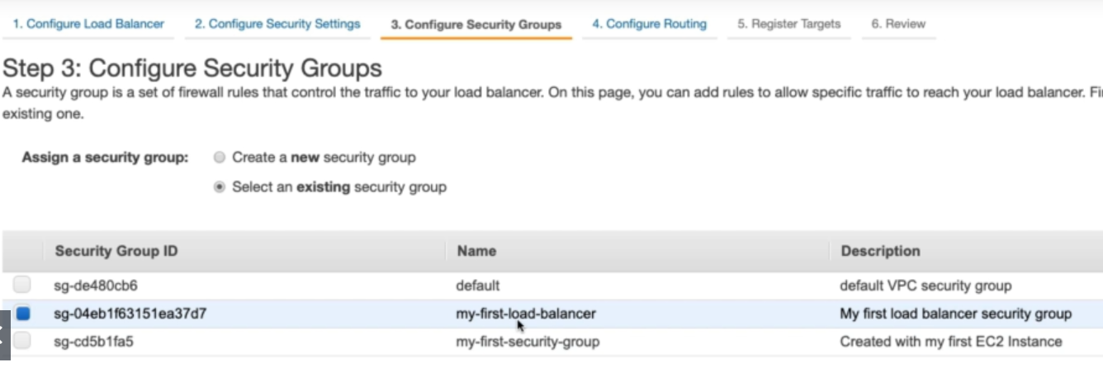

* Security group settings same as classic load balancer.

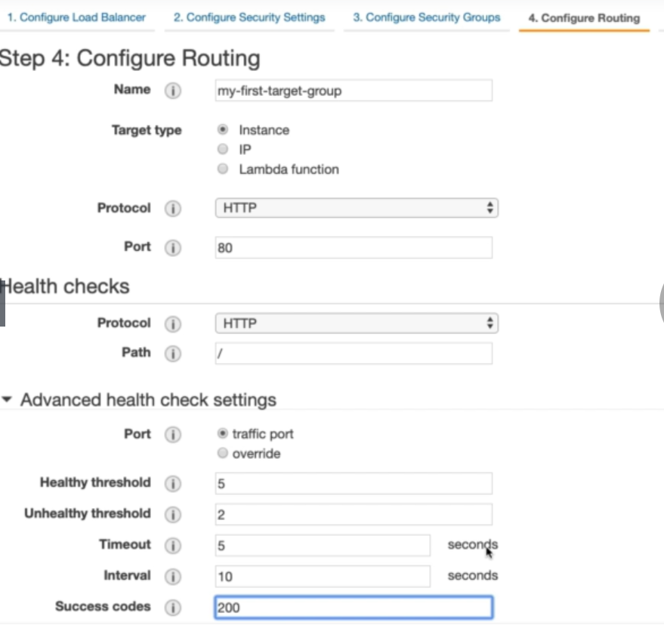

* Configure routing in next step as above. We need to give a name for the target group, protocol and the port.

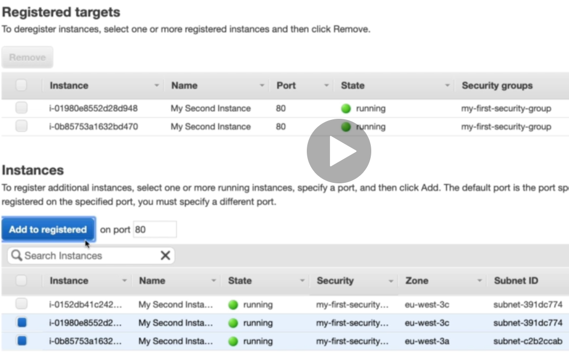

* Now, we need to register the instances to target groups
* Once all done. We can review everything and create load balancer.
* If the target instances are healthy. We can try accessing with the load balancer’s DNS and check.

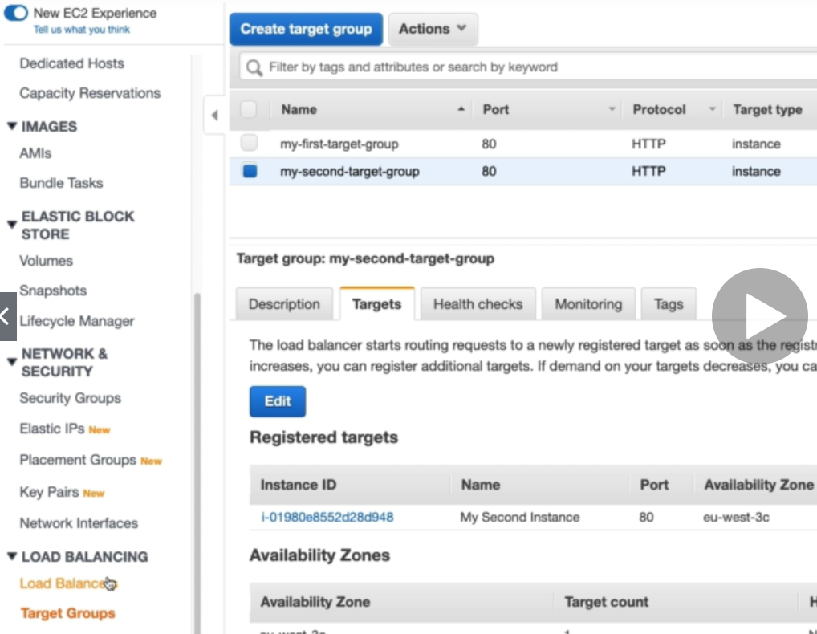

* We can create multiple target groups and add it to the load balancer.

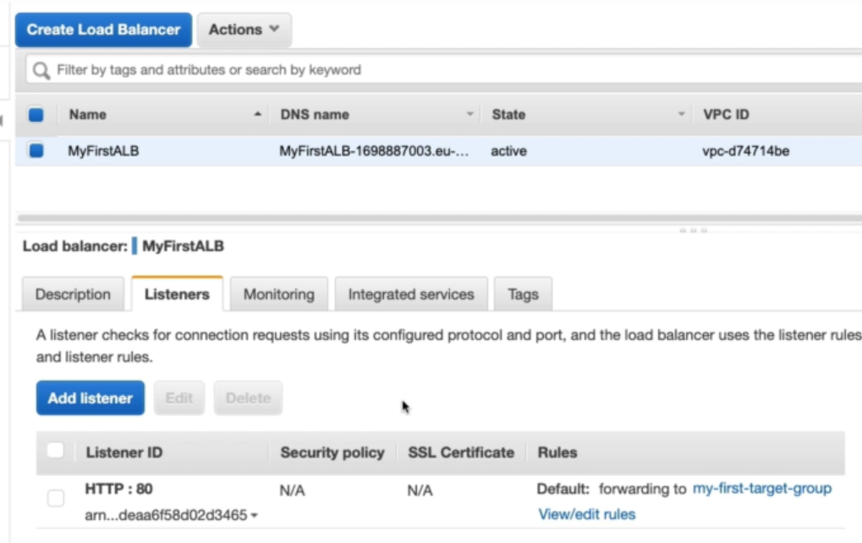

* we can click on edit rules and do as below.

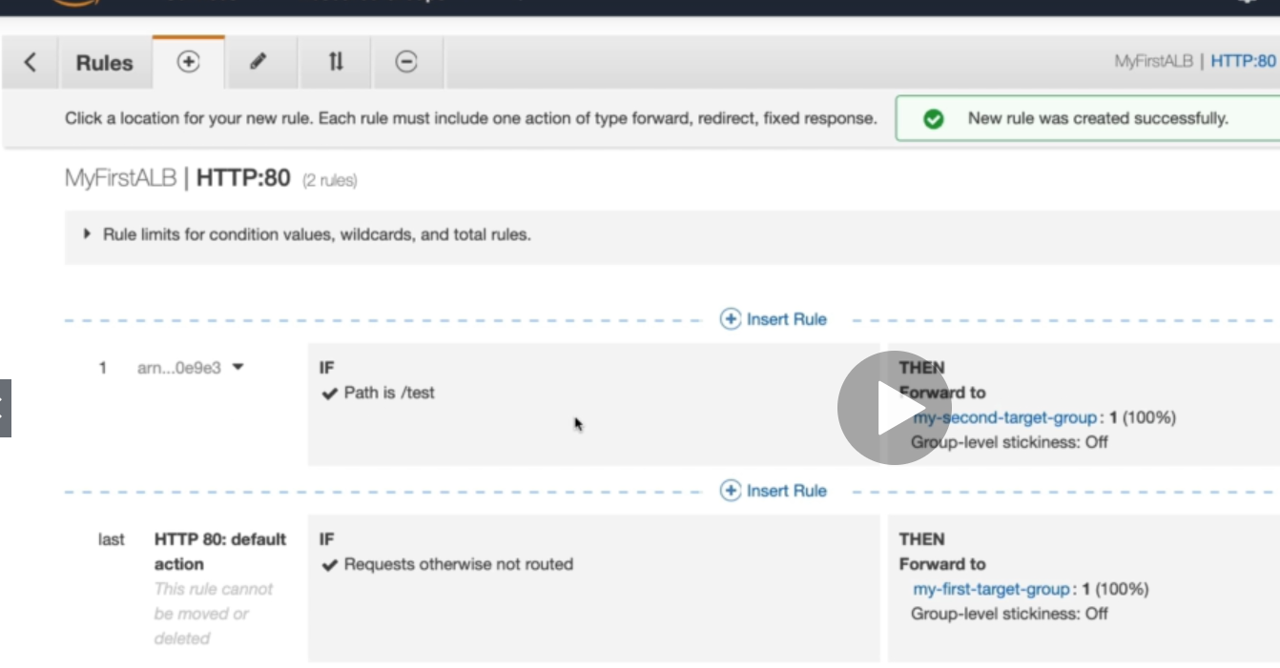

* We can add new rule with the path
* As above, if a request comes to “/test”. It will go to second target group.

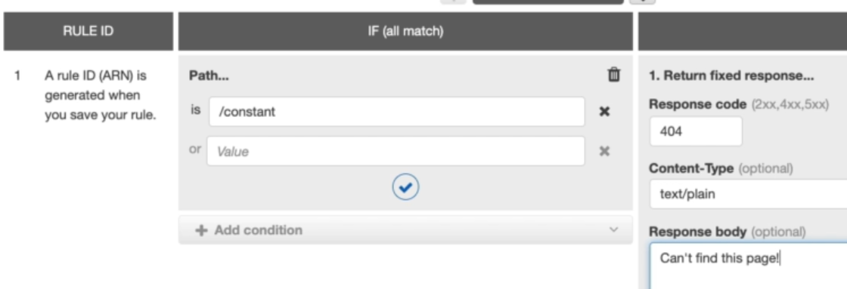

* We can also return a fixed response by selecting it with a message if a request comes to particular path as above.

Now, if we use DNS name with target group. It will route the traffic to that group only

* **DNS name/steller/steller.tml**